**PROJECT**

**Weather Condition Analysis using SQL**

**1. Create a table “Station” to store information about weather observation stations:**

ID Number Primary key

CITY CHAR(20)

STATE CHAR(2)

LAT_N Number

LONG_W Number

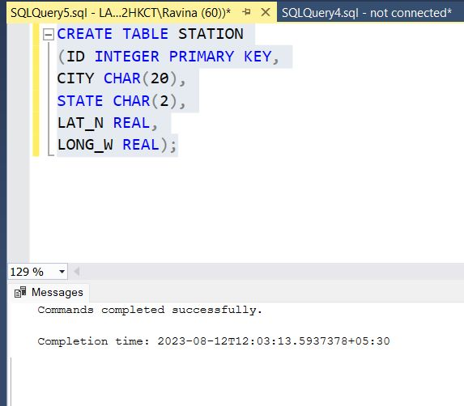

Use primary key for not allowed to duplicate ID.

**2. Insert the following records into the table:**

|  |
| --- |
| ID CITY STATE LAT_N LONG_W |
| 13 PHOENIX AZ 33 112 |
| 44 DENVER CO 40 105 |
| 66 CARIBOU ME 47 68 |

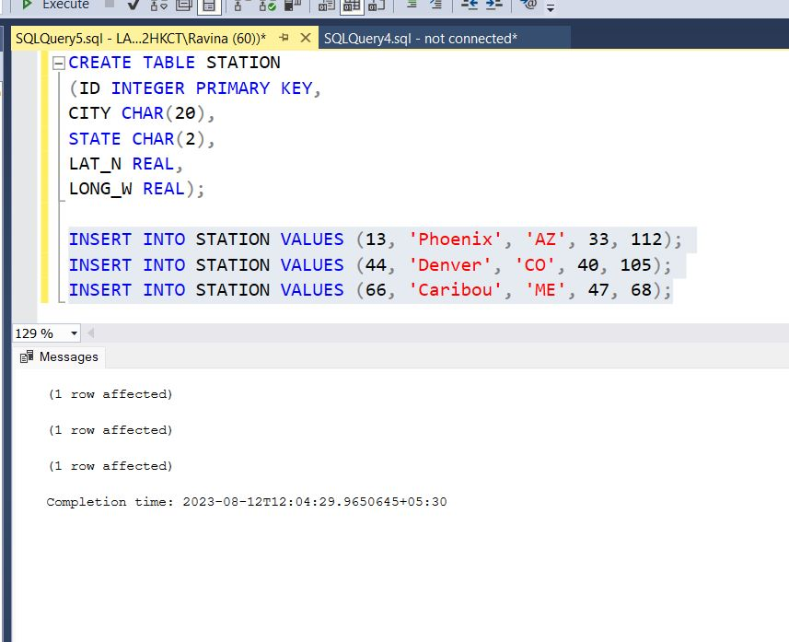

Inserted values in station table.

**3. Execute a query to look at table STATION in undefined order.**

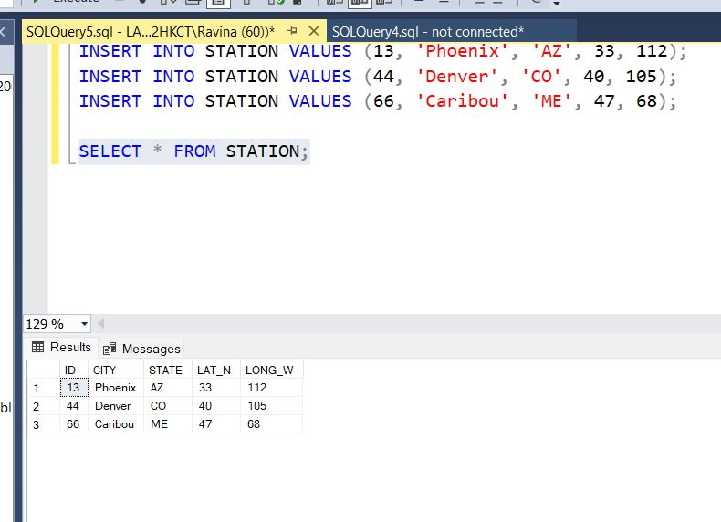 USED SELECT * FROM TABLE_NAME Query to display table.

**4. Execute a query to select Northern stations (Northern latitude > 39.7).**

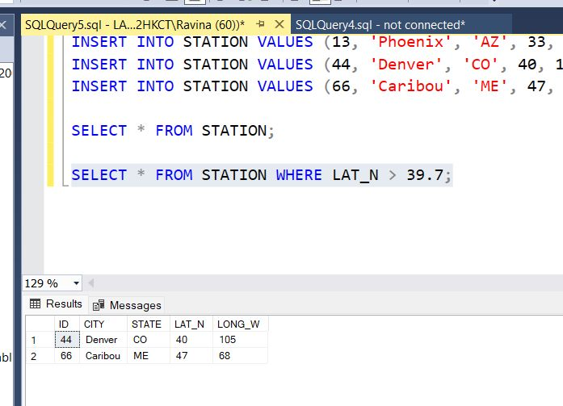

LAT_N is Stand for Northen latitude so by executing above query found ID 44 and 66 has 40 and 47 LAT_N Respectively.

**5. Create another table, ‘STATS’, to store normalized temperature and precipitation data:**

|  |
| --- |
| Column Data type Remark |
| ID Number must match some STATION table ID(so name & location will be known.) |
| MONTH Number Range between 1 and 12 |
| TEMP_F Number in Fahrenheit degrees, Range between -80 and 150 |
| RAIN_I Number in inches, Range between 0 and 100 |

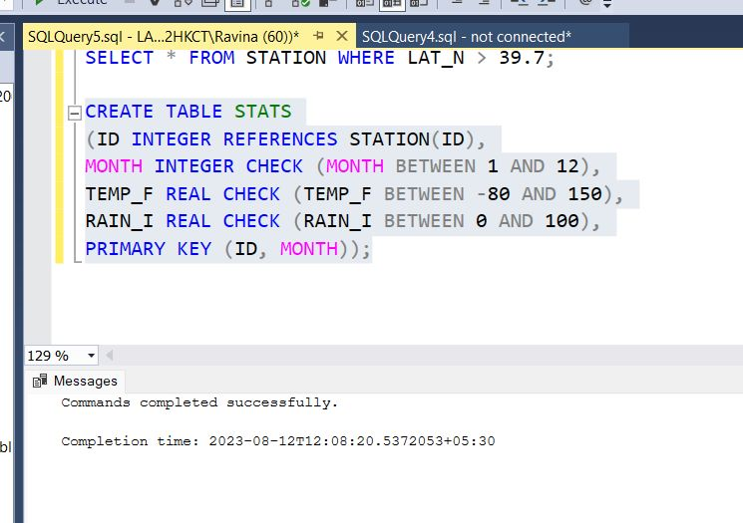

Another table has Created as ‘STAS’ for weather condition analysis . in this table TEMP_F is Stand for Temperature is in Fahrenheit degree and RAIN_I means Rainfall is in inches.

**6. Populate the table STATS with some statistics for January and July:**

|  |
| --- |
| ID MONTH TEMP_F RAIN_I |
| 13 1 57.4 .31 |
| 13 7 91.7 5.15 |
| 44 1 27.3 .18 |
| 44 7 74.8 2.11 |
| 66 1 6.7 2.10 |
| 66 7 65.8 4.52 |

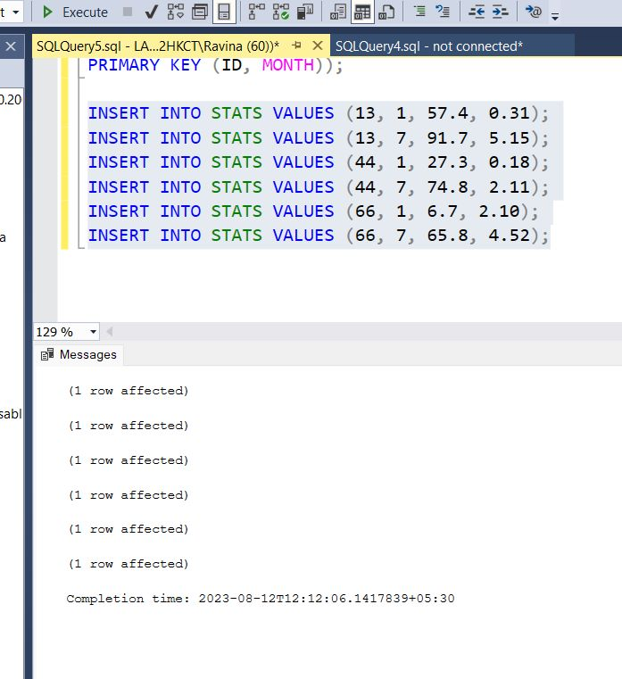

Successfully Inserted values in Stats Table.

**7. Execute a query to display temperature stats (from STATS table) for each city (from Station table).**

Used inner join to join both Stats and Station table to each other. And retrieved the data city wise temperature.

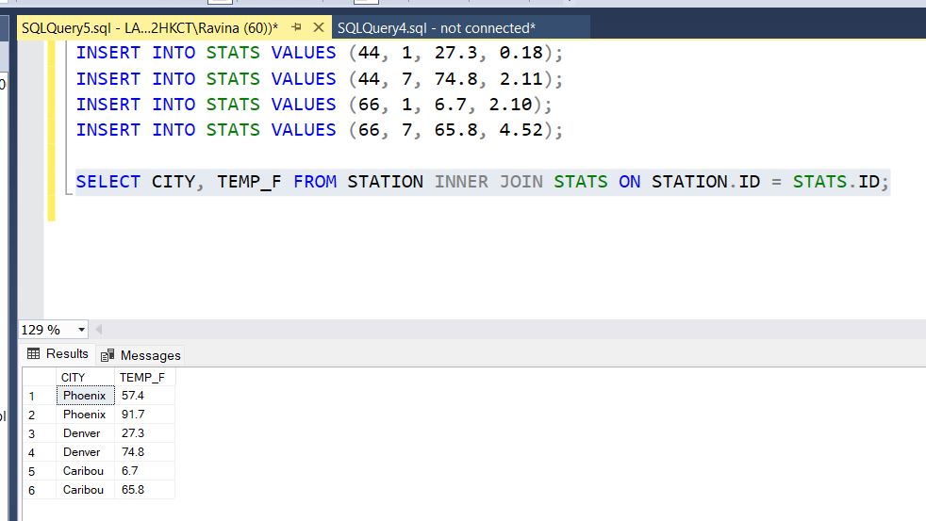

**8. Execute a query to look at the table STATS, ordered by month and greatest rainfall, with columns rearranged. It should also show the corresponding cities.**

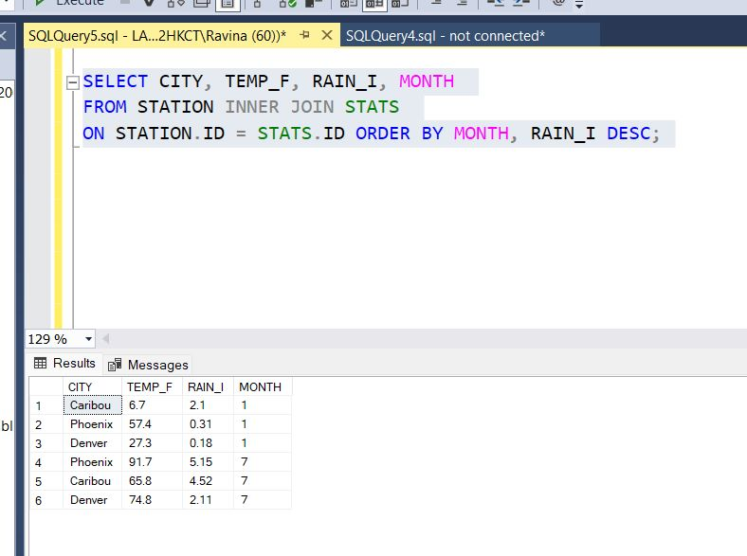

Greatest rainfall in January month is 2.1 in Caribou city And in July month is 5.15 rainfall in Phoenix.

**9. Execute a query to look at temperatures for July from table STATS, lowest temperatures first, picking up city name and latitude.**

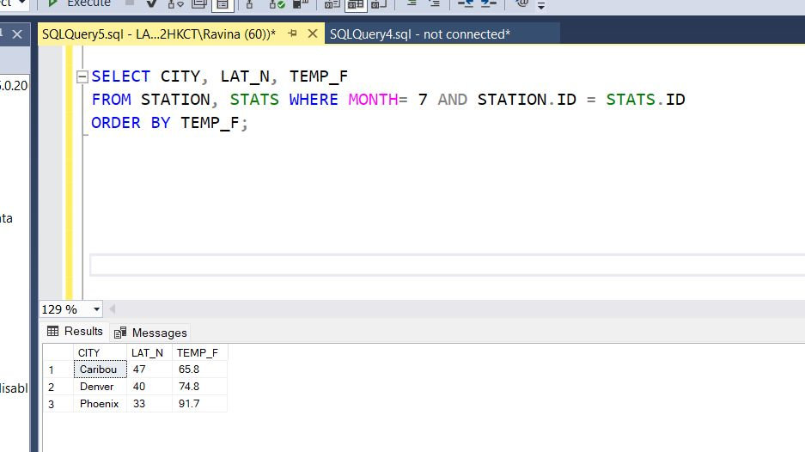

Lowest temperature in Caribou and latitude is 65.8 in the July month.

**10. Execute a query to show MAX and MIN temperatures as well as average rainfall for each city.**

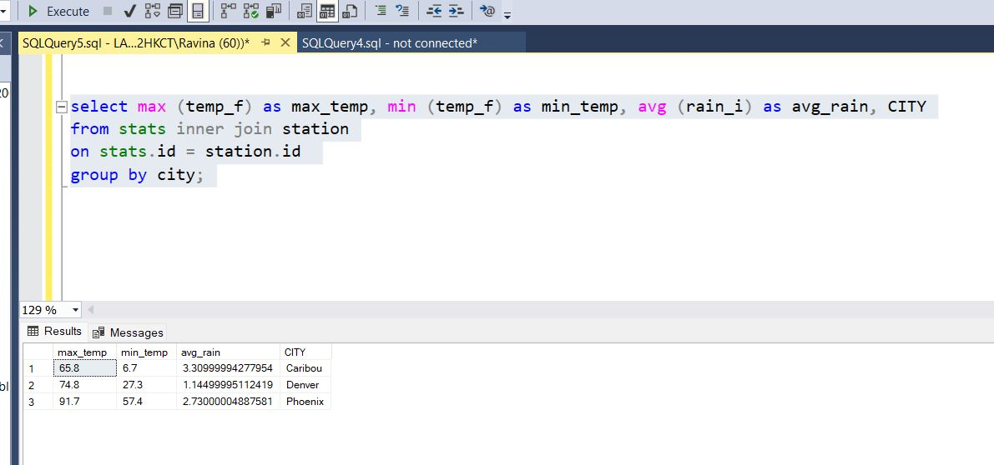Maximum temperature is 74.8 in Denver city. Minimum temperature is 6.7 is in Caribou city.

**11. Execute a query to display each city’s monthly temperature in Celcius and rainfall in Centimeter.**

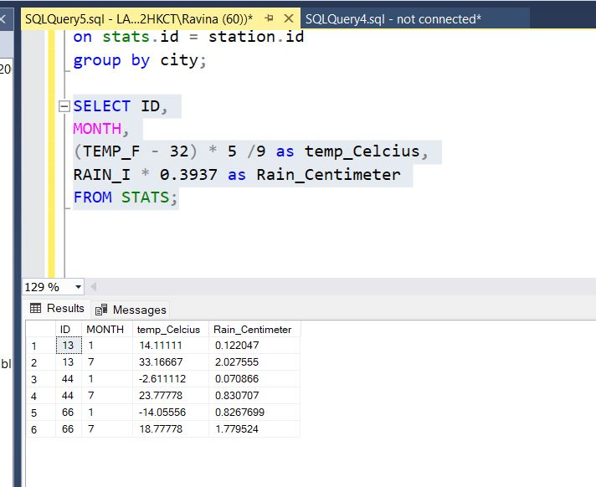

Converted Temperature degree Fahrenheit into Celcius and rainfall inches into centimeter.

**12. Update all rows of table STATS to compensate for faulty rain gauges known to read 0.01 inches low.**

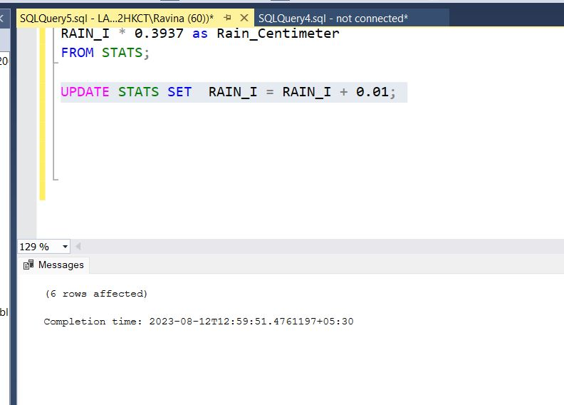

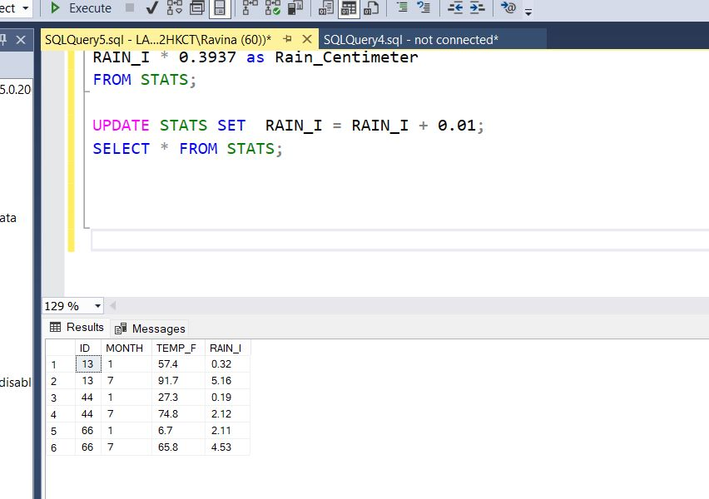

Update the RAIN_I column From Table STATS by adding 0.01 in each row.

**13. Update Denver’s July temperature reading as 74.9**

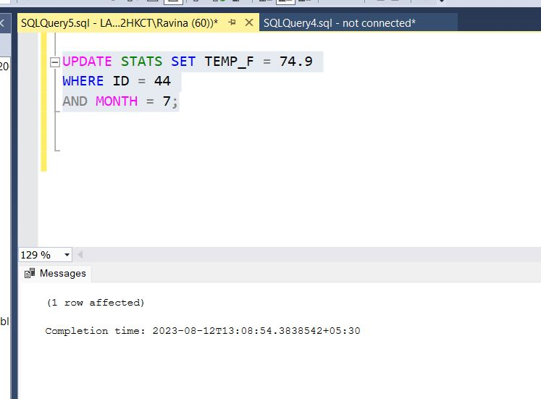

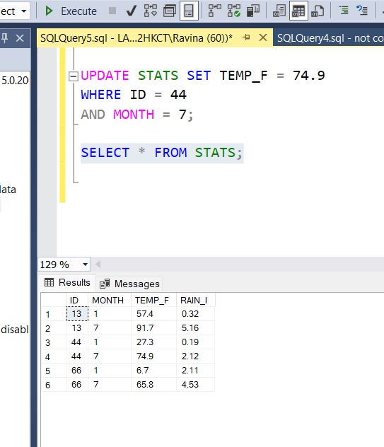

Updated the row from table Stats where temperature was 74.8 by 74.9 by using where clause.